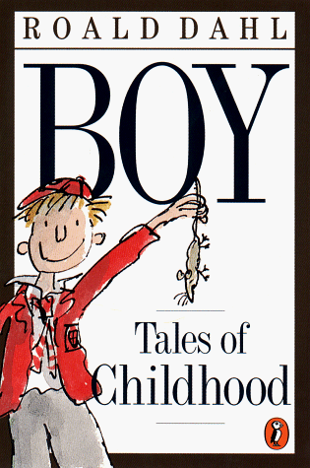

Author: Roald Dahl
Illustrated By: Quentin Blake

Published By: the Penguin Group
Date of Publication: 1999

Setting

When and where the autobiography takes place

This book is an autobiography of Roald Dahl written in 1984. It began in Sarpsborg, Norway where Roald’s father, Harald, was born.

Then it moved on to Paris where Harald settled and went into business. A few years later, Harald was able to buy a fine house in the village of Llandaff for his newly married wife, Marie. After giving birth to her second child, Marie died.

During the summer of 1911, while taking a trip in a small coastal steamer in Oslofjord, Harald met a young Norwegian lady named Sofie Magdalene Hesselberg. They married soon after and went back to live in the Llandaff house. Roald was born on September 13, 1916. Later, they had many children, so a larger and grander house was needed. In 1918, when Roald was two, they all moved into an imposing country mansion beside the village of Radyr, about eight miles west of Cardiff. It was a mighty house with turrets on its roof surrounded by majestic lawns. There were terraces all around the mansion. Many acres of farm and woodland surrounded the mansion as well. There were a number of cottages for the workers. The meadows were filled with all kinds of different farm animals.

When Roald was six years old, he went to his first school. It was a kindergarten called Elmtree House. When he was seven, he left kindergarten and went to a proper boy’s school. It was called Llandaff Cathedral School about a mile from their house. He attended that school between the ages of seven and nine. In September 1925, when Roald was just nine, he went to boarding school. It was in a part of England and very close to their home in South Wales. It was called St. Peter’s School. On September 1929, when Roald was thirteen, he entered a famous public school called Repton. The family was living in Kent then, in a place called Bexley. Repton was up in the Midlands, near Derby.

Synopsis

This book is an autobiography of Roald Dahl written in 1984.

Roald’s father, Harald Dahl, was a Norwegian who came from a small town near Oslo, called Sparsborg. He and his brother, Oscar Dahl decided to go away to a big country to go into business. They separated in Paris and started to make large fortunes. When Harald moved to South Wales, he already had a wife, a young French girl called Marie whom he had recently married in Paris. Marie bore him two children, a girl and a boy. But tragically, she died after giving birth to the second child. So Harald went back to Norway and there he met a young lady, Sofie Magdalene Hesselberg. They married soon after. During the next six years she bore him four children, three girls and Roald who was the only boy. He was born on September 13, 1916 in Llandaff, Wales.

In 1920, when Roald was still only three years old, his seven-year-old sister, Astrid Dahl, died from appendicitis. His father Harald passed away of pneumonia soon after, at the age of 57. So his mother, Sofie, was left alone to raise two step-children and four of her own children. And she was expecting their fifth child in two months time. Nevertheless, his mother was determined to keep the family in Britain rather than head back to Norway and live with her relatives because her husband wished to have their children educated in English schools. He thought they were the best schools in the world, even better than the Welsh schools. As soon as their mother had her fifth child, they moved to Cumberland Lodge in Llandaff because they couldn’t manage the big house anymore.

Two years later, Roald became six years old. He went to his first school, Elmtree House. It was a kindergarten run by two sisters, Mrs. Corfield and Miss. Tucker. After kindergarten, Roald first attended Llandaff Cathedral School, between the ages of 7 and 9. At the age of eight, Roald and four of his friends were caned by the headmaster after putting a dead mouse in a jar of sweets at the local sweet shop owned by a "mean and loathsome" old woman, Mrs Pratchett. At the end of the school year, he went back home. The family owned a new car and Roald’s half-sister took them on a car trip. Unfortunately, she didn’t learn how to turn, so they had a car accident. Nobody was hurt, except for Roald. His nose was almost cut clean off his face. It was hanging by only one thread of his skin. Very Tragic!

When Roald Dahl was 9, he was sent to St Peter's Preparatory school, a private school in the seaside town of Weston-super-Mare, which he attended from 1925 to 1929. It was a boarding school. He was very homesick and wrote to his mother almost every day. From 13, he was educated at Repton School in Derbyshire, where he was a fag for a prefect, became captain of the school Fives team and developed an interest in photography. During his years at Repton, Cadbury, a chocolate company, would occasionally send boxes of new chocolates to the school to be tested by the pupils. Dahl himself apparently used to dream of inventing a new chocolate bar that would win the praise of Mr. Cadbury himself.

After finishing his schooling, he spent three weeks hiking through Newfoundland with a group called the Public Schools' Exploring Society. In July 1934, he joined the Shell Petroleum Company which sent him to Africa for three years to sell Shell oil. That was where he started his career.

Opinions

“Boy” by Roald Dahl is a captivating story about a young boy's childhood. It was a good book for me for many reasons. Roald is the author who wrote a lot of the books that I enjoyed such as Matilda, The Witches, and The Magic Finger. “Boy” is very humorous and interesting. I never knew Roald got into so much trouble during his childhood. This great autobiography is different from most other ones. It doesn't just list boring facts that don't interest the readers. Instead, it tells the readers about many strange and wonderful events that happened in Roald Dahl's childhood such as he was a chocolate candy tester for Cadbury’s, he was involved in the Great Mouse Plot of 1924, and he nearly lost his nose in a car accident. It is life through a little boy's eyes. You just can't stop reading once you pick up this book. Roald Dahl definitely had an interesting life as a child.

I think readers ages 10 and up should read this book. It teaches you about life. I would give this book a rating of five stars out of five stars. I recommend that people should read Roald’s autobiography after reading some of his famous novels such as James and the Giant Peach, Charlie and the Chocolate Factory, and Danny and the Champion of the World.

Your bookshelf is not complete without it! So go get it!

Miscellaneous

The other books written by Roald Dahl:
- The BFG
Illustrated by Quentin Blake. Farrar, Straus and Giroux, 1982.
Sophie is saved by the BFG and finds herself in a strange environment.
- Charlie and the Chocolate Factory
Illustrated by Joseph Schindelman. Knopf, 1964.
Charlie and four of his less than wonderful friends tour on extraordinary chocolate factory. They all meet with disaster except for Charlie.
- Danny, the Champion of the World
Illustrated by Jill Bennett. Knopf, 1975.
Dad helps Danny try to save the birds of the woods before Mr. Hazell's shooting party.
- The Magic Finger
Illustrated by William Pene Du Bois. HarperCollins, 1966.
When her neighbors shoot and kill animals, a little girl uses her "magic finger."
- Matilda
Illustrated by Quentin Blake. Viking-Kestral, 1988.
Genius Matilda rids her school of mean headmistress Trunchbull.
- The Witches
Illustrated by Quentin Blake. Farrar, 1983.
A boy and his grandmamma save English children from being turned into mice by witches.

The titles of other books similar to Boy - Tales of Childhood:
- J.K. Rowling: A Biography - The Genius Behind Harry Potter
- Emily Carr: An Introduction to Her Life and Art
- Mozart: A Life
- Lemony Snicket: The Unauthorized Autobiography
II
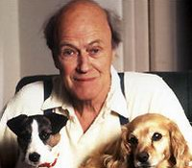
This is Roald with his two dogs

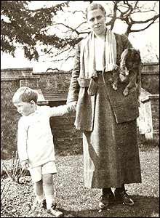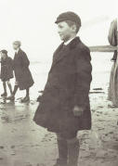
Three year old Roald and his mother St. Peter’s Uniform

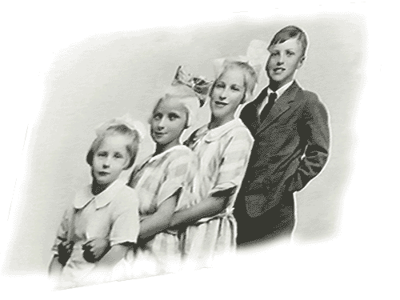
Alsa Else Alphild Roald

Cardiff 1927

